RGB Adapter (CoCo3 to AppleColor RGB)

# Overview

The CoCo3 is an amazing machine, but it is not known for having great RF and Composite video output. A preferred route is to use the RGB port on the bottom of the machine to display GIME’s video on an Analog RGB Monitor. The result is a much clearer and crisper picture.

The GIME chip has separate signals for the two video formats, CVIDEO, and RGB Video. You can see the pins on the chip here:

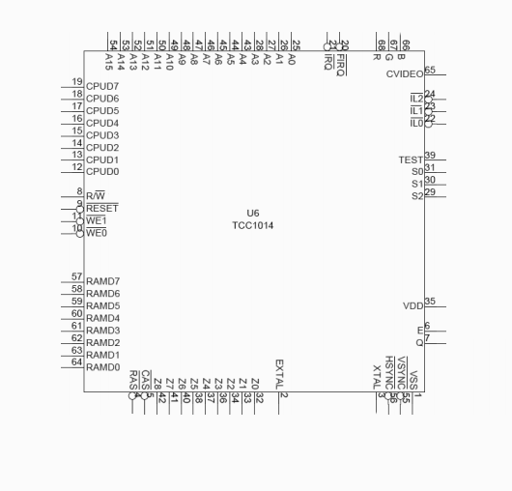

The CVIDEO line carries all the video data and synchronization information in one signal. The RGB video on the other hand, requires the use of two additional signals used for synchronization: HSYNC and VSYNC. These two signals tell the monitor when a video line starts (HSYNC) and when the page frame begins (VSYNC).

Here are the two signals in action. The top signal is HSYNC and the bottom signal is VSYNC. Notice how the top signal is pulse much more rapidly than the bottom signal. That is because the top signal is pulsed for every line drawn and bottom is once per page.

**HSYNC**

**VSYNC**

# Apple RGB Monitor

The AppleColor RGB monitor for the IIgs is an **analog** monitor. The RGB signals vary in amplitude and that indicates the intensity of that color. For example, full voltage on the G signal would mean the brightest green, and no voltage on the G signal would mean no green at all.

The RGB signals coming out of the CoCo3 match this format and are compatible with the monitor. However, the video synchronization signals are not.

The Apple monitor requires the both the HSYNC and the VSYNC to be in the same signal. In addition, the monitor requires the signals to be **active low**. This means they will remain at a high voltage level and then drop to a low level when triggered. This means the monitor needs the signals to be inverted from what the CoCo3 provides.

# Composite Sync (CSYNC)

A composite video sync signal looks very different:

Here you can see the HSYNC pulses go from high to low very frequently with the VSYNC going to low voltage when it is active. During that time, the HSYNC reverses direction and goes from low to high.

Very complicated.

Fortunately, we can accomplish this transformation with four XOR logic gates, arranged like this:

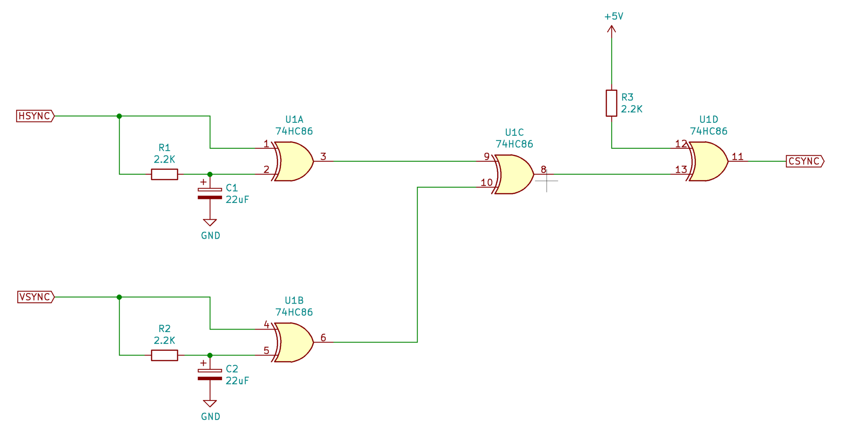

# Adapter Board

The board is a small card measuring 79mm x 49mm and contains all the electronics to convert the HSYNC and VSYNC to CSYNC. The CoCo3’s RGB signals are passed through to the monitor untouched.

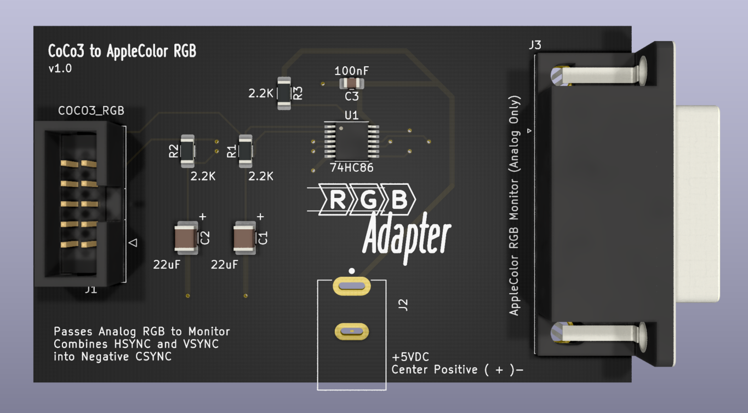

The unit requires a 5VDC power supply using a DC barrel connector 5.5mm x 2.5mm plug:

